

##### ENC 1102 30050 and 32150

**Freshman Composition II**

**Summer 2024 Credit Course**

**Professor Information**

Nicole Spottke

**Email:** [nspottke@valenciacollege.edu](mailto:nspottke@valenciacollege.edu)

**Phone:** (407) 582-1935

**Office Location:** WC 1-238A

**Student Engagement Hours:** Valencia College students can expect to have timely access to faculty outside of class. Refer to your course Canvas space or other supplemental course information for details on your professor’s preferred means and times of communication.

**Course Information**

**Credit Hours:** 3

**Class Meeting Times:** ONLINE

**Course Description:** Application of skills learned in ENC 1101. Emphasis on style; use of library; reading and evaluating available sources; planning, writing, and documenting short research paper. Gordon Rule course in which the student is required to demonstrate college-level writing skills through multiple assignments. Minimum grade of C required if ENC 1102 is used to satisfy Gordon Rule and general education requirements. This course will focus on a variety of literary genres, with some emphasis on works by international authors.

**Course Outcomes**

* Apply a multi-stage research process to produce essays.
* Compose a written argument using evidence from varied sources.
* Apply conventions aligned to varied writing situations.
* Document source material in accordance with at least one recognized documentation style.
* Apply critical reading skills.

**Attendance**

Online attendance is required and necessary for receiving information. Logging on only once a week is not sufficient and does not count as attendance. To get the most of this course, you are responsible for logging in and checking mail messages, announcements, grades, and discussion messages at least once every four days.

If you are unable to participate in the course due to illness, family emergency, etc., please communicate with me as soon as possible to create a plan to complete any missed assignments so your learning can progress in your course. In the case of a prolonged online absence, please communicate with me as soon as possible to create a plan for the best course of action. Do note, sometimes the best course of action is to take a medical withdrawal and repeat the course.

**Academic Honesty**

All forms of academic dishonesty are prohibited at Valencia College. Academic dishonesty includes, but is not limited to, acts or attempted acts of plagiarism, cheating, furnishing false information, forgery, alteration or misuse of documents, misconduct during a testing situation, facilitating academic dishonesty, and misuse of identification with intent to defraud or deceive.

If a faculty member concludes a student in their class has violated this policy, the faculty member can choose to assign academic penalties that include, without limitation, one or more of the following: loss of credit for the assessment (assignment, examination, project, paper, etc.); a reduction in the course final grade; a grade of “F” as the final grade in the course. The faculty member may also refer the violation for action in accordance with Policy 6Hx28:8-03, Student Code of Conduct.

Plagiarism is the use of someone else’s words, ideas, pictures, design, and/or intellectual property without the correct documentation and punctuation. Your professor has a no-tolerance approach to plagiarism.

Students’ work will be submitted to Turnitin for verification of originality. If you submit wholly or partially plagiarized work, you will be penalized for the offense. This includes reusing old work from a previous class without permission from your professor.

If you are cutting from somewhere and then pasting into your writing without

1. Quotation marks,
2. Citations, *and*
3. A bibliographic entry on the works cited page, then you are plagiarizing.

If you take a passage from a source, a single sentence, or more without appropriately citing the source information, you will receive an F in the course. Offering a sentence, sentences, a full paragraph(s), or even a full essay will result in an F in the course. In extreme circumstances, academic action will be taken against you. Read the [Academi](https://valenciacollege.edu/students/disputes/academic-integrity.php)c Dishonesty policy found in Valencia’s online policy manual.

**AI Usage Policy:**

Regarding AI tool usage in this course, any time you use an AI tool in this class, please identify the tool, mark which portions of your work come from or have been influenced by the tool, and share how the tool enriched your learning. You will also provide the professor with the link to the AI discussion. Work submitted with AI-created or influenced portions that have not been marked and analyzed will not earn points and will put the student at risk for disciplinary inquiry.

AI tends to repeat a particular set of words. If you are seeking assistance from AI, looking to sound smarter, AI is not the best way to accomplish this. Here is a list of words used by past students in their writing. Notice how this set of words was rarely used prior to AI. It is best to avoid these words, please.

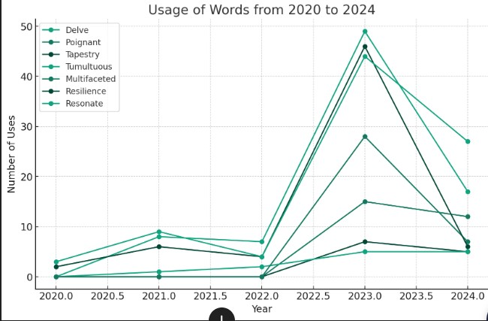

**Student Code of Conduct**

Valencia is dedicated not only to the advancement of knowledge and learning but also to the development of responsible personal and social conduct. As a registered student, you assume the responsibility for conducting yourself in a manner that contributes positively to Valencia's learning community and does not impair, interfere with, or obstruct [the orderly conduct, processes, and functions of the college as described](https://valenciacollege.edu/about/general-counsel/policy/documents/volume8/8-03-student-code-of-conduct.pdf) [in the Student](https://valenciacollege.edu/about/general-counsel/policy/documents/volume8/8-03-student-code-of-conduct.pdf) [Code of Conduct.](https://valenciacollege.edu/about/general-counsel/policy/documents/volume8/8-03-student-code-of-conduct.pdf)

**Disclaimer Statement**

Changes to this syllabus, schedule, and/or policy may be made at any time during the course per instructor discretion. These changes will be reasonable and made in the best interest of student learning. Students will be notified of any changes either in class, through Announcements, and/or via the Canvas Inbox conversations tool. Students with any concerns about any changes should discuss it with the instructor as soon as possible.